**BCVD1007 – Full Stack Development II – Lab 5**

* DOM Manipulation & Traversal

**Developer Note:**

* Use the web documents and window web api

References:

<https://developer.mozilla.org/en-US/docs/Web/API/Document>

All Exercise starter code can be found in the following git repository  
<https://tinyurl.com/y62dtf52>

**Exercise 1:**

Create a html document named **Ex1.html** and a function named **displayChildElements** that has the following requirements:

* Invoked **displayChildElements** within the page and takes no parameters
* Outputs to the console the following

1. select the container element

2. output the container element child nodes

3. output the first child node

4. output the first element child

5. output the last child node

6. output the last element child

Use the starter code found here:  
<https://tinyurl.com/y62dtf52>

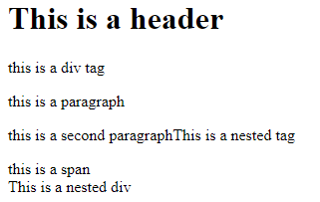  
The expected output should be as follows:  
  
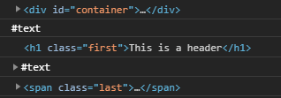

**Exercise 2:**

Create a html document named **Ex2.html** and a function named **displaySiblingElements** that has the following requirements:



Use the starter code found here<https://tinyurl.com/y62dtf52>

* Invoked **displaySiblingElements** within the page and takes no parameters
* Outputs to the console the following
  + select the element with the class **main-pa**r (using **querySelector method**)
  + output the **previous sibling element**
  + output the **next sibling element**

The expected output should be as follows:  
  
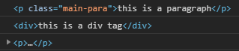

**Exercise 3:**

Create a html document named **Ex3.html**

Use the starter code found here: <https://tinyurl.com/y62dtf52>

* Build the HTML output in the following way
  + select the element with the container ID (using **querySelector method**)
  + create a paragraph element and append it to the container element
  + create a span element and append it to container element
  + create a h1 element and append container element

**The HTML Document should render as follows**:

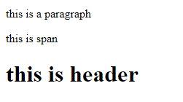

**Exercise 4:**

Create a html document named **Ex4.html**

Use the starter code found here: <https://tinyurl.com/y62dtf52>

* Build the HTML output in the following way
  + select the element with the container ID (using **querySelector method**)
  + remove all the child elements of the container element

**The HTML Document should render as follows**:  
